# HTML – Lesson 2

## List

An unordered list starts with the <ul>tag. Each list item starts with the <li> tag.

The list items will be marked with bullets (small black circles).

Example:

<ul>  
  <li>Coffee</li>  
  <li>Tea</li>  
  <li>Milk</li>  
</ul>

You can also create ordered list with the tag <ol></ol>The list items will be marked with numbers.

Example:

<ol type="1">

<li>Item in list…</li>

<li>Item in list…</li>

<li>Item in list…</li>

</ol>

## LINE BREAK

The <br> tag inserts a single line break.

Note: The **<br/>** tag is an empty tag which means that it has no end tag.

Example:

<p>Be not afraid of greatness.<br>  
Some are born great,<br>  
some achieve greatness,<br>  
and others have greatness thrust upon them.</p>  
  
<p><em>-William Shakespeare</em></p>

## QUOTE AND BLOCKQUOTE TAG

* The <blockquote>tag defines a short quotation.
* Browsers normally insert quotation marks around the quotation.
* <q> is called an **inline element** because it can be put inside a line of text without affecting it

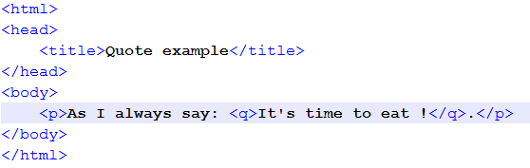

* The [<cite>](https://developer.mozilla.org/en-US/docs/Web/HTML/Element/cite)tag specifies a section that is quoted from another source.
* Browsers usually indent <blockquote> elements.
* <blockquote> is called an **block element** because it cannot be put inside a line of text. A block element will create a line break to outside the current line.

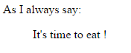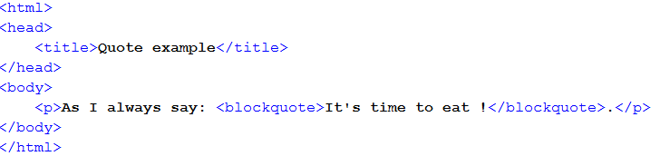

## INLINE AND BLOCK ELEMENTS

Most HTML elements are defined as block level elements or inline elements.

Paragraph normally start (and end) with a new line, when displayed in a browser.

Examples:

<p>This is a paragraph.</p>  
<p>This is another paragraph.</p>

<div> are normally displayed without line breaks.

Examples:

<div class="label">My Label:</div>

<div class="text">My text</div>

## NESTED ELEMENTS AND HTML TREE

HTML elements can be nested (elements can contain elements).

All HTML documents consist of nested HTML elements. This hierarchy can be represented in a tree

*In the below example, P and H1 are nested in BODY. BODY is nested in HTML*

<!DOCTYPE html>  
<html>  
  
<body>  
  <h1>My First Heading</h1>  
  <p>My first paragraph.</p>  
</body>  
  
</html>